**CA3001 – Programming and Data Structures using C**

**Assignment 6** **- 11.01.2021**

**Q1.** Calculate the sum of numbers (10 numbers max) & If the  user enters  a  negative number, the  loop terminates.  
Ans – C Program & Ouput:

#include <stdio.h>  
int main()

{  
int i,sum=0,n;  
for(i=1;i<=10;i++)  
{  
printf("enter number %d:",i);  
scanf("%d",&n);  
if(n>=0)

sum+=n;  
else  
break;  
 }  
printf("the sum of the  numbers is:%d",sum);  
return 0;  
}  
  
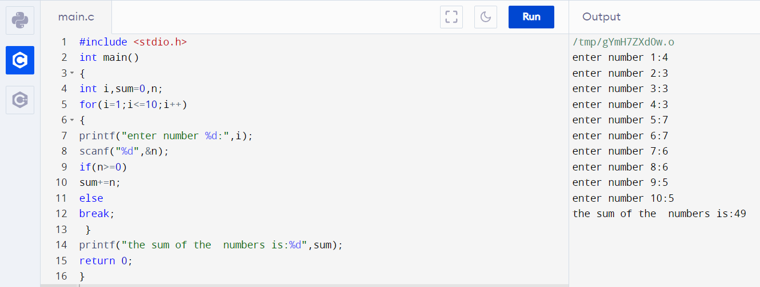**Q2.**  Calculate the sum of numbers (10  numbers max) & If the  user enters  a  negative number, it's  not  added  to  the  result.  
Ans – C Program & Output:

#include <stdio.h>  
int main()

{  
int i,sum=0,n;  
for(i=1;i<=10;i++)  
{

printf("enter number %d:",i);  
scanf("%d",&n);  
 if(n>=0)  
 sum+=n;  
 }  
printf("the sum of the numbers is:%d",sum);  
return 0;  
}  
  
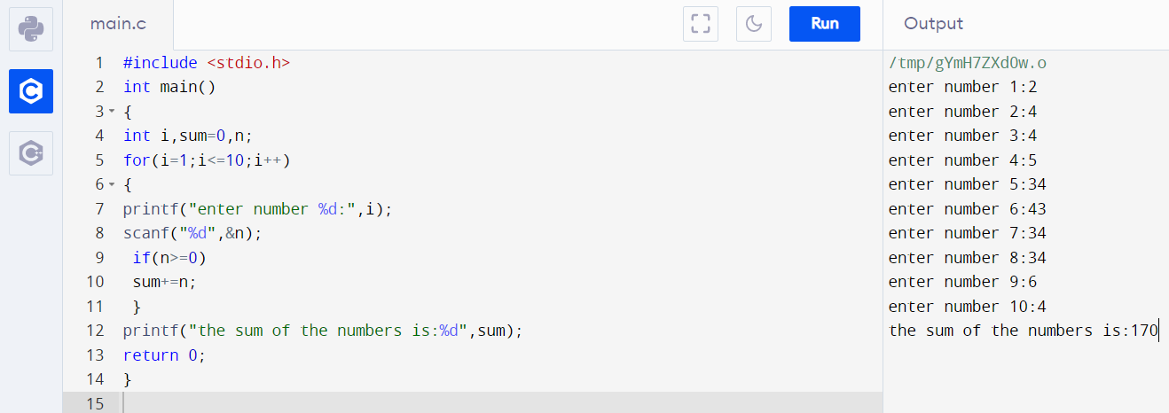

Q3. Take input from the user until he/she enters the zero (Using Break).  
Ans – C Program & Output:

#include <stdio.h>  
int main()

{  
int n;  
do  
{  
printf("input data:");  
scanf("%d",&n);  
}

while(n!=0);  
printf("ERROR!!!\n no further input possible");  
return 0;  
}

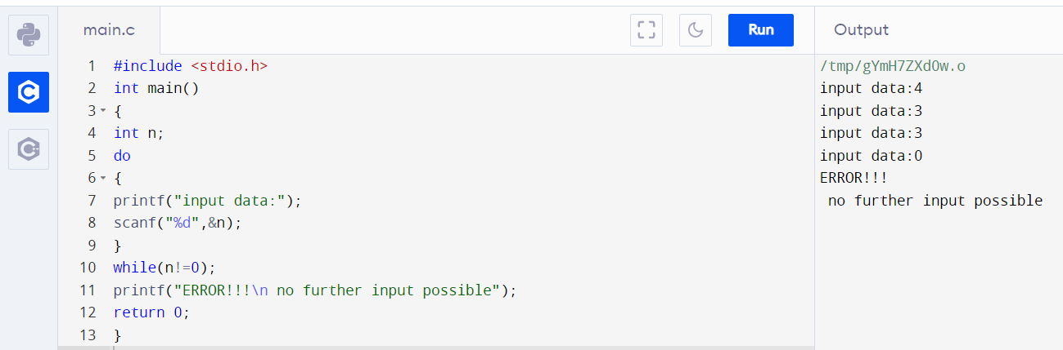

**Q4**.  Check whether the given number is prime

Or not.(Using  Break)  
Ans – C Program & Output:

#include <stdio.h>  
int main()

{  
 int p=1,n,i=2;  
printf("enter a number to determine prime or not:\n");  
scanf("%d",&n);  
 do

{  
 if(n%i==0||n==1)  
{

p=0;  
break;  
}  
i++;  
}

while(i<n/2);

if(p==0&&n!=2)  
printf("%d is not a prime number",n);  
else  
printf("%d is a prime number",n);  
 return 0;  
}

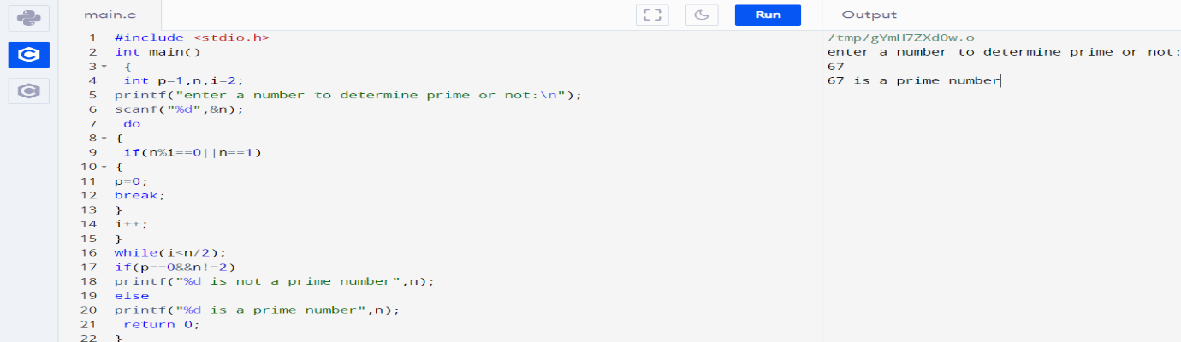  
  
  
**Q5.** Print sum of odd numbers between 0 and 10. (Using Continue)  
Ans – C Program & Output:

#include <stdio.h>  
int main()

{  
int i,sum=0;  
for(i=0;i<=10;i++)  
{  
if(i%2!=0)  
sum+=i;  
continue;  
}  
printf("sum of odd numbers 0 to 10 is:%d",sum);  
return 0;  
}

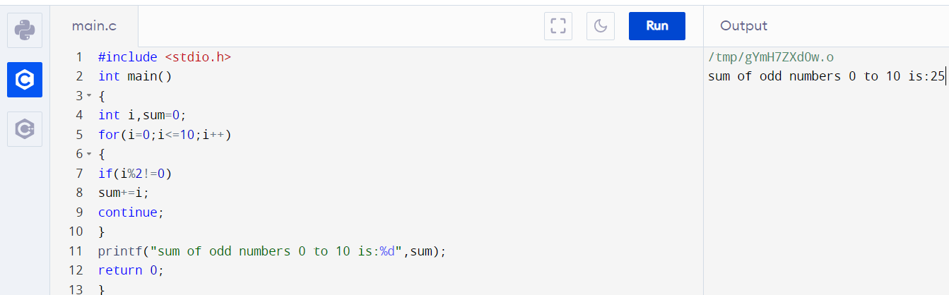  
  
**Q7.** Print all even numbers from 1 to 100. (Using Continue)

Ans – C Program & Output:

#include<stdio.h>  
int main()

{  
int i;  
for(i=1;i<=100;i++)  
{  
if(i%2==0)  
printf("%d\t",i);  
continue;  
 }  
 return 0;  
 }

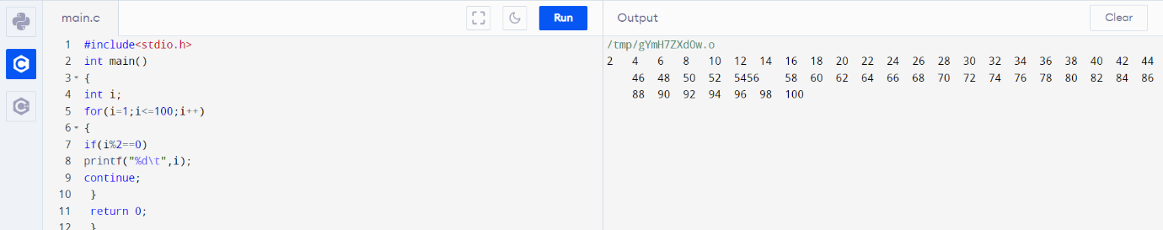  
  
**Q8**. Print numbers from 1 to 10 using goto statement. (Using goto)

Ans – C Program & Output:   
#include <stdio.h>  
int main()

{  
 int i=1;  
 print:  
 printf("%d\n",i);

i++;  
if(i<=10)  
goto print;

return 0;  
}  
  
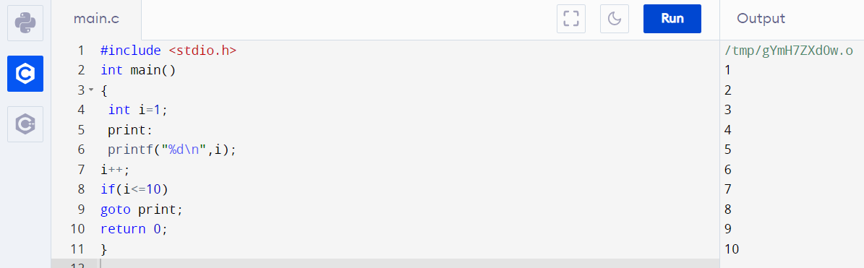  
  
**Q9**. Program to calculate the  sum  and average of positive  numbers,  If  the  user  enters a negative number,  the  sum  and average are displayed (Using  goto)

Ans – C Program & Output:  
#include <stdio.h>  
int main()

{  
int i=1,j,n,sum=0,count=0;  
printf("enter the number of input you want \n");  
scanf("%d",&j);  
printf("enter the numbers:\n");  
while(i<=j)

{  
scanf("%d",&n);

if(n<0)  
{  
goto display;  
 }  
sum+=n;  
i++;  
count++;  
}  
display:  
printf("the sum is: %d\n",sum);  
printf("the avg is: %d",sum/count);

return 0;  
}  
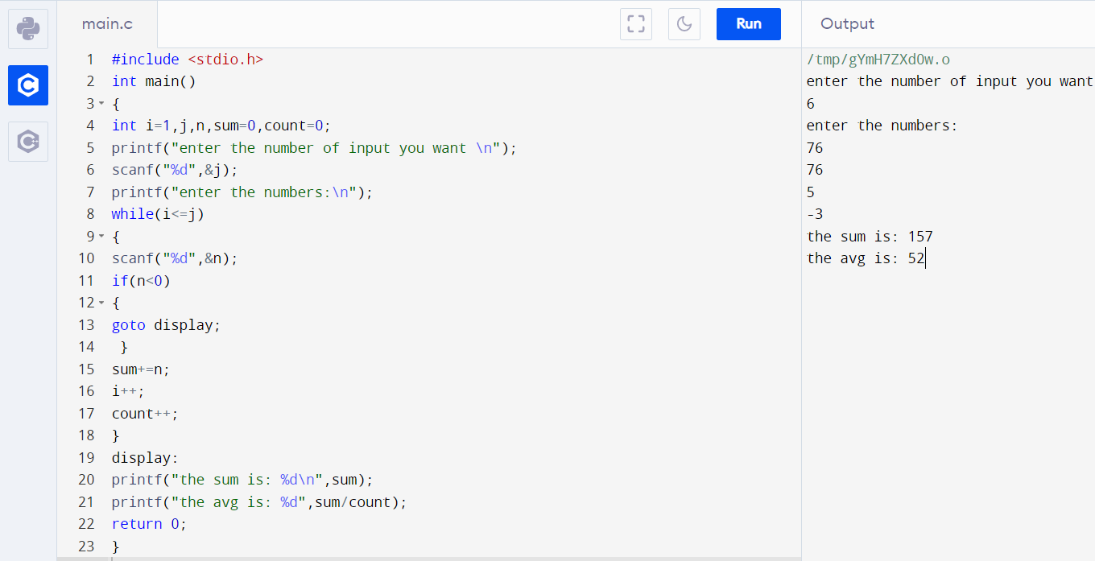

**Q10.** Check  if a number is even or not. (Using goto)  
Ans – C Program & Output:

#include <stdio.h>  
int main()

{  
int n;  
printf("enter a number to check is even or not\n");  
scanf("%d",&n);  
if(n%2==0)  
goto even;  
else  
goto odd;

even:  
printf("%d is even",n);  
return 0;  
odd:  
printf("%d is odd",n);  
return 0;  
}

